Whitewater Rafting Website Plan

**Logo**

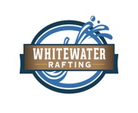

**Color Palette**

primary-color: #eccd9d;

secondary-color: #D99E41;

background-white: #FFFFFF   
  
text-color: #000033;  
  
Coolors Palette Link: <https://coolors.co/palette/74498f-000033-ffffff-ccff88-d99e41-e1b167-e7c185-eccd9d>

**Typography**

font-family: 'Merriweather', serif

font-family-alt: 'Roboto', sans-serif